The development of IPv6 technology in Malaysia, issues and solutions

Gopinath Rao Sinniah (gopi@nrg.cs.usm.my)

Asian Institute of Medicine, Science and Technology (AIMST),
2, Persiaran Cempaka, Amanjaya,
08000 Sungai Petani,
Kedah, Malaysia
http://www.aimst.edu.my

Abstract

Internet has been very busy and demanding for the last 10 years. One of the most popular events in Internet today is IPv6. This new protocol which is going to replace the current IPv4 is at its peak with lots of research being carried out. Although IPv6 provides enhancements to IPv4 with some new features, its deployment and development in Malaysia is rather slow compare to other countries such as Japan and Europe [2]. This is due to few internal and external factors.

This paper examines the development of IPv6 technology in general and specifically in Malaysia. The discussion also includes the issues towards slow deployment and research in IPv6 in Malaysia and also the possible solutions. Beside that, possible research areas that can be explored would also be discussed.

1. Introduction

Nothing in the recent years that has grabbed the imagination of so many as the Internet. The over demanding of Internet has doubled in size since 1988. There are over 44 million hosts on the Internet and with the current growth, it is estimated that by the end of the decade, IPv4 addresses would be exhausted. To overcome this problem, several approaches have been made. The most well known and widely used approaches are Network Address Translator (NAT) and Classless Inter-Domain Routing (CIDR). These two approaches made the IPv4 address to last longer than expected.

IPv6 is introduced mainly to solve the address space issues. With its large amount of addresses and with other features, IPv6 is estimated to replace IPv4 in a very near future.

Some of the IP experts said that the bottom line for IPv6 deployment is going to be the worldwide demand for Internet Addresses. Some even said that the demand for IPv6 is primarily in Europe and Japan, which is primarily related to address space.

Whatever the arguments are, these countries and regions have proved to be the leaders in IPv6 technology with their research and development on this protocol. The intensive research which is supported by Japanese Government is an example to the rest of the world. Today, they have outlined standards that are to be used by the rest of IPv6 community.

Japan’s WIDE [11] project, US’s 6REN/6TAP [10] and Europe’s 6INIT [9] are just to name a few of the major IPv6 projects around the world. As a developing nation, Malaysia needs to follow the footstep of these gigantic approaches by these countries, at least a portion of it. But due to some issues, the deployment and development of IPv6 in Malaysia is moving slowly than expected.

This papers’ objective is to study the IPv6 development in Malaysia. In section 2, the current status of IPv6 development in Malaysia will be discussed and in section 3, the issues involved in the deployment and development of IPv6 research will be presented. The strategies to overcome these issues will be discussed in section 4 while section 5 discusses about the intended future research. Lastly, the conclusion and the future direction will be presented.

2. IPv6 in Malaysia

Even though IPv6 was introduced in Malaysia 6 years back, the progress of the research development is rather slow. Since NTT Japan is active in IPv6, it has brought the IPv6 culture into Malaysia when their branch, NTT MSC Malaysia was opened. This was rather a good introduction that is inline with Multimedia Super Corridor (MSC) objectives and in the long run will benefit the country. NTT MSC is the pioneer for IPv6 in Malaysia.

With the involvement in APAN [1], AI3 and other organization, IPv6 has started off quiet smoothly even though in a small scale. Tunelling has been tested, the stack has been analyzed and drafts and papers have been published [5,6,7]. These also eventually generated some post graduated students.

Some of the early users of this protocol for its research are NTT MSC, Network Research Group (NRG) and Malaysian Advanced Network Integrated System (MANIS).

To compete with other countries in the IT world, NTT MSC has been taken the role to introduce a broad array of IPv6 solutions which includes Native IPv6 connectivity, IPv6 over IPv4 Tunneling, IPv6 Web-hosting and IPv6 Co-location Services. This strategic and extensive IPv6 service launched by Arcnet6 [4], NTT MSC’s brand name for Internet Service will mark the revolutionary move to the advancement of this protocol in Malaysia. This will eventually promote other research groups to be more active.

Malaysian Advanced Network Integrated System (MANIS) who is active in IPv6, has successfully set up and offers the tunneling service. 6 of public Universities have peered with MANIS to access to IPv6 world. MANIS also have tunnel broker to connect to 6Bone network. Figure 1 below shows the connection to MANIS.
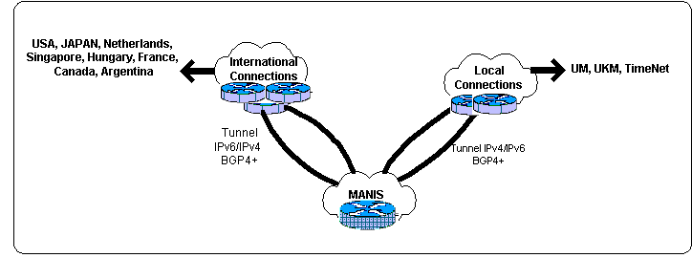
Figure 1: IPv6 Tunneling connectivity by MANIS

There are mainly 3 organizations that are distributing IPv6 addresses from APNIC.

- APAN
A number of IPv6 blocks have been allocated for research. The IPv6 address which is being allocated by APAN which is handled by NTT MSC starts from 2001:0200:0701::/48.

- MANIS
The IPv6 addresses for research institution, the allocations will start from 3ffe:80d0:ff00::/48 to 3ffe:80d0:ff50/48.
For other organizations, the allocation starts from 3ffe:80d0:fe00::/48 to 3ffe:80d0:fe50::/48.

- AI3 Malaysia
This organization has a block address of 2001:0200:0860::/44 to be distributed and used. AI3 members are interconnected by satellite link

Another upcoming area is Third Generation (3G) wireless protocol. 3G only landed in Malaysia 1 or 2 years back even though it has already available in other established countries. Recently the Malaysian Communication and Multimedia Commission (MCMC) has awarded 3G licenses to 2 telecommunication companies, Telekom Malaysia and Maxis Communication. Malaysian government in a way encourages this 3G implementation, maybe after seeing that we are far behind the technology. The research in wireless and 3G is still at large here. Even though thorough research has been carried out world wide, there are still large areas that can be enhanced.

To get more detail on the number of people that is aware of IPv6, MANIS has conducted online survey [3]. The people participated in this survey can either be researchers or normal Internet users because details of the participants are not collected. So the survey is not precise. Based on that survey, out of 317 people, 20% are not aware about IPv6. The statistics are as follows:

- 64% of them felt that IPv6 will be implemented after 5 years. This is shown in figure 1 below.
- Over 50% gave positive response towards moving to IPv6
- Over 40% of them have the competency to move to IPv6.

Figure 2: Survey on the expected duration for IPv6 migration

To get more precise detail on the awareness on IPv6 in Malaysia, another survey in a larger scale will be conducted, with details of the participants.

3. Issues

There are few factors that have contributed towards the slow rate of IPv6 development and deployment in Malaysia.

- Coordination and information sharing
Until now researches are not coordinated among the research groups. Because of this most of the organizations do not share their research information to others. This is

- Lack of awareness and exposure (internationally)
Many of the end users are not aware of the changes that is taking place in the Internet world especially IPv6 and because of this, the importance of IPv6 remains unknown and this creates lack of demands for IPv6.

- Funding
There are a lot of ideas that has been generated by local network experts in IPv6, but because lack of funding, the ideas either has been dropped or given to organizations that are willing to develop the idea.

Because lack of funding, a lot of IPv6 experts are not able to attend international and well known conferences and seminars. Exposure to such conferences is important because the IPv6 will gain more understanding on IPv6.

The other problem is the interest of institutions to participate in IPv6 research. This can be seen with the number of IPv6 blocks that has been allocated. Even though plenty of IPv6 blocks available, only few institutions and organizations obtained these addresses for their use. This also shows the level of awareness and lack of publicity in Malaysia.

4. Strategies

To be competitive in Internet Technology, specifically IPv6, a program has been outlined with collaboration from few research institutions and organizations. This is to follow the foot steps of Japan (IPv6 promotion council) [8].

This programme (Figure 2 in appendix) which is a proposal is yet to get approval from the Government. It consist of 6 modules with each one is explained the following sections.

- Training and Human Resource
Proposed actions include sketching out the syllabus and IPv6 course guidelines for academicians from undergraduates to post graduate studies. This course guidelines and syllabus will be used to create IPv6 programmers and experts thru various Universities and other educational institutions throughout the country.
Besides providing human resource, this program will also assist and conduct workshops, trainings and talks on IPv6 issues to increase awareness and keep the Malaysian community up to date with current advancement and protocol evolution process.

- Core Research and Development
This part will be discussed further in section 5.

- Monitoring and Resource Allocation
Monitor and manage the IPv6 address allocation. Even though the IPv6 addresses would be distributed evenly, unlike IPv4, but it necessary for a body to monitor this addresses.

Various monitoring tools from both external and self developed would be used and tested to monitor the network.

- Policies and Migration
This section will outline the policies concerning to IPv6 deployment and provide consultation to various organizations in migratory issues. Policies consist of action plan and standard step by step guide for migration will be distributed throughout the country through various affiliates and collaborators.

- IPv6 Middleware Development
In this part, tools, intermediate application and libraries for users and developers will be created. This middleware development will benefit software developers and researchers in terns of developing IPv6 technology and software.

- Infrastructure
Infrastructure is a main part in IPv6. In this part, assistance will be given for organizations to get the infrastructure needed for the migration. An IPv6 backbone across the country is needed to link all the research institutions, organizations and local ISPs.

To monitor the progress on this programme, a council would be created. This council would promote the IPv6 to the end users through media. This is to create awareness among the end users which later will create the demand for IPv6. The awareness program consists of the new services and technologies that IPv6 will drive.

The council/committee that will be formed would ideally compromise of the following groups. Each of this group can carry out work in its own area of specialization in IPv6 Malaysia. The WG are as follows.

- Service providers
- Research and Development
- Regulatory
- Legal
- Vendors
- Governmental

5. Future Research and implementation

While the process of spreading the news and promoting Malaysian organization and generally the public to use the new next generation Internet protocol is important, core research and development should not be forgotten or neglected.
IPv6 still has a lot of areas that need to be looked into. These research areas can be categorized into few sections as below.

- Home Appliances
- Security
- 3G/4G
- Medical and Biotechnology
- Multimedia
- Satellite
- Automobile and Transportation Manufacturers
- Others

Asian Institute of Medicine, Science and Technology (AIMST) has taken the initiative to setup and use IPv6 network in the new campus which will be ready by next year. Plans are being outlined for this purpose.

This means, the new campus will be fully available for IPv6 connectivity. Research in Home Appliance, Medical and Biotechnology using IPv6 is part of the programme in AIMST.

6. Conclusion

A lot of work is still at large in promoting IPv6 services and technology in Malaysia. Government intervention could increase the growth rate of IPv6 deployment in Malaysia. With the proposed strategies, it is expected to produce more IPv6 developers, experts and eventually provide some research work that can be shared. This will not only make Malaysia as part of IPv6 but also will be a great source for IPv6 researchers worldwide.

References

[1] APAN IPv6 Malaysia. http://www.my.apan.net/ipv6

[2] SANS. “IPv6 Deployment in Malaysia: The Issues and Challenges”, 4th April 2002. http://www.sans.org/rr/country/malaysia.php

[3] MIMOS Berhad. “MANIS: IPv6 survey results”. http://www.manis.net.my/vote/ipv6.htm

[4] ARCNET6, NTTMSC. First IPv6 ISP in Malaysia. http://www.arcnet6.net.my

[5] S. Gopinath Rao, K. Ettikan & R. Sureswaran. “IPv6 Hostname auto-registration Procedure”, <draft-gopinath-ipv6-hostname-auto-reg-02>, December 2002.

[6] S. Gopinath Rao, K.Ettikan & R. Sureswaran, “Host Name Resolution Protocol (HNRP) for IPv6 Addresses – A study on existing implementation and the need for a new protocol”, Proceedings 5th IEEE Malaysia International Conference on Communications + LISLO, Kuala Lumpur, Malaysia , 21st – 24th October 2001

[7] S. Gopinath Rao, P. Arul, S. C. Lim, T. S. Phang & K. Ettikan, “Online APAN IPv6 Network Monitoring”, Proceedings Asia Pacific Advanced Network Conference, Shanghai, China, 26th – 28th August 2002.

[8] Japan IPv6 Promotion Council. http://www.v6pc.jp/en/index.html

[9] EU fifth frame work, IPv6 Internet Initiative. http://www.6init.com/

[10] US IPv6 Research and Education Network (6REN). http://www.6ren.net/

[11] Japan’s WIDE project. http://www.wide.ad.jp/about/index.html

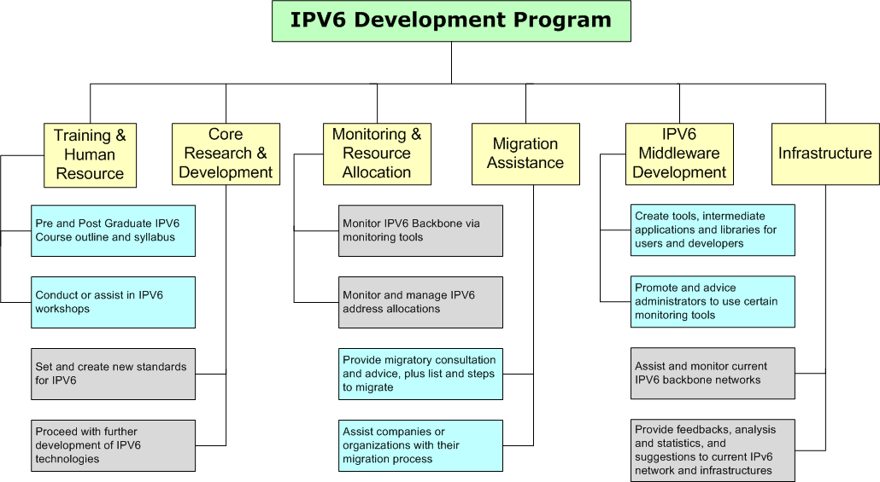
Figure 3: Malaysian IPv6 Development Program

